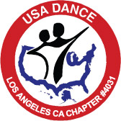

USA Dance
Los Angeles Chapter #4031
Board of Directors Meeting
June 16, 2008

AGENDA

Welcome Harris

Approval of Minutes Harris

Treasurer’s Report Barbara

Chapter Discussion Bill Rose
Governance Procedures

Chapter Dance Parties Harris
Mayflower Dance – Lessons Learned
Schedule Going Forward

Chapter Officer Succession Harris

Marketing Update Livia

Membership Status Sherry

Gabriella Foundation/Student Program Update Michele

“Survey Monkey” Results Michele

New Business

